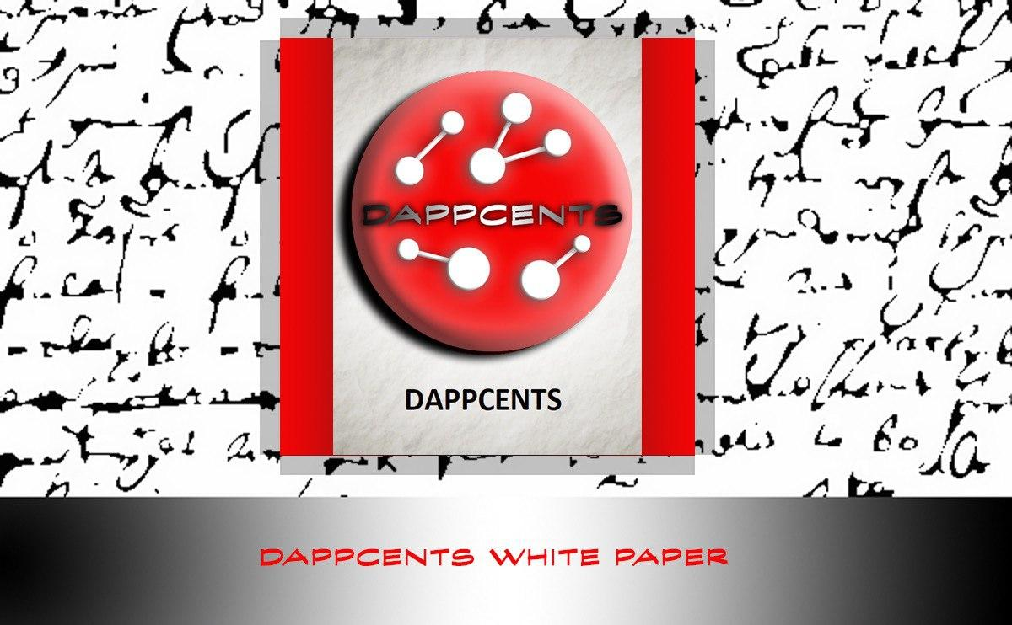

**INTRODUCTION**

We strive to help build communities for the best DAPPs (Decentralized Applications) in the crypto space using social media. Dappcentre platform consists of social media outlets such as: Telegram, Discord, Twitter, Facebook, Instagram, and most importantly our monetized YouTube channel. Dappcentre provides marketing services to crypto related businesses to help promote their products, while also building a community for their platforms. All profits made from monetization; referral commissions, & sponsorships will be distributed to all token holders.

**TOKEN**

DAPPCENTS (DPC) is a TRC-20 token on the TRON Blockchain. ICO (Initial Coin Offering) price is .25 TRX per token. All profits made from Dappcentre platform will be distributed to all DAPPCENTS token holders on a monthly basis. Dappcentre will live stream via Youtube on Dappcentre’s financial performance on a monthly basis, so there is full transparency on Dappcentre’s performance. All the profits made from monetization, referral commissions, & sponsorships will be converted into TRX and will be added to the dividend pool. Smart Contract will distribute the TRX in dividend pool to all DAPPCENTS holders by the 7th day each month. The more DAPPCENTS tokens you hold the more dividends you will receive in the pool.

Contract Address: TEm2pMqgjnbvgNQi1gFYBZH9BfMu123mbW

Issuer Address: TLnLRb3CGGtdEcucWn4MS6m5cpuyyFVaS4

Total Supply: 100,000,000

Circulating Supply: 89,472,966

Issue Date: 2020-08-06

Token ID: 1003129

**TOKENOMICS**

ICO (INITIAL COIN OFFERING) – 30 %

CONTENT CREATORS – 25%

DEVELOPMENT TEAM – 15%

BUYBACK PLAN – 10%

MARKETING – 10%

AIRDROP – 9.47%

RESERVED -0.52%

**SMART CONTRACT FUNCTIONALITY**

DPC (DAPPCENTS) started as a TRC-10 token and has now been converted to TRC-20 token with smart contract functionality. All dividends can be distributed to every DPC token holder autonomously monthly. The dividend pool will be filled with TRX at the end of each month when we do our financial performance review via LIVE STREAM.

**ROADMAP**

|  |  |  |  |  |
| --- | --- | --- | --- | --- |
| **AUGUST**  **2020** | **SEPTEMBER 2020** | **OCTOBER**  **2020** | **NOVEMBER**  **2020** | **DECEMBER**  **2020** |
| * **DAPPCENTS TRC-10 TOKEN RELEASED**      * **WHITE PAPER RELEASE** * **PARTNERSHIPS** * **NEW SOCIAL MEDIA OUTLET** * **SMART CONTRACT BEING DEVELOPED** | * **FIRST MONTHLY BUSINESS REVIEW VIA LIVE STREAM** * **FIRST DIVIDENDS DISTRIBUTED TO TOKEN HOLDERS**      * **DAPPCENTS TRC-20 TOKEN BEING DEVELOPED (IF NEEDED)** * **MARKETING PLAN FOCUSING ON LEAD MEASURES** | * **TOKEN SWAP 1 FOR 1 IF TRC-20 TOKEN**   **NEEDED**   * **EXCHANGE LISTING ANNOUNCEMENT** * **IMPROVE CONTENT CREATION** * **WEBSITE UPGRADE** | * **HAVE OVER 5K SUBSCRIBERS ON YOUTUBE** * **SPECIAL PROMOTION ANNOUNCEMENT** * **ICO TOKEN SALE ENDS NOVEMBER 31ST** * **FIRST BUY BACK FOR TOKENS TO BE BURNED** | * **TOKEN LISTED ON EXCHANGE** * **COINGECKO LISTING** * **TOKEN LISTED ON CASINO WEBSITES** * **COMPLETE FIRST TOKEN BURN** * **FIRST ANNUAL EXECUTIVE MEETING VIA LIVE STREAM** |

**BUY BACK PLAN**

10 million DAPPCENTS (10% of the supply) will be held in the burn address TMdSFcxsKkf62eL9PgA6G2jmsZF3QCa5do

All dividends distributed to this address will be used to buy back DAPPCENTS to stabilize the price.

All DAPPCENTS tokens bought back will be burned deflating the token supply and increase token value.

First token burn is planned to be completed by the end of 2020.

**DIVIDEND POOL**

All profits made on the Dappcentre platform will be converted into TRX based off the current market price at the time the conversion is taken place. The conversion will occur at the end of each month and the dividend pool will be filled by the 1st of each month. You can view the Dividend pool balance on TRONSCAN and will be updated real time as the dividend pool grows.

DIVIDEND POOL ADDRESS: **TVV1z5cRSnVvztintK73hc31z7CubZKQSM**

2,000 have been added to the Dividend pool and is frozen for bandwidth & energy to avoid transaction fees. Subtract 2,000 TRX from the total TRX balance to get the total Dividend pool amount.

**DIVIDEND DISTRIBUTION BREAKDOWN**

To help incentivize participation in obtaining more DPC, there will be a minimum holding requirement to be eligible for dividends. You can earn DPC by participating is the LIVE STREAM events via TWITCH & DISCORD. Community members can also earn DPC by completing tasks assigned my admin via TELEGRAM. The minimum requirement to receive dividends will increase every month which will also increase the token value. The first round of dividends minimum requirement was 1000 DPC to receive dividend. This amount will increase to 5000 DPC for the 2nd month and will increase 1000 DPC each month after that until reaching the MAX minimum requirement of 100,000 DPC to receive dividends. Dividend Distribution Breakdown:

1st month = minimum of 1000 DPC to receive dividends

2nd month = minimum of 5000 DPC to receive dividends

3rd month = minimum of 6000 DPC to receive dividends

4th month = minimum of 7000 DPC to receive dividends

5th month = minimum of 8000 DPC to receive dividends

6th month = minimum of 9000 DPC to receive dividends

7th month = minimum of 10000 DPC to receive dividends

…… each month will increase 1000 DPC until it reaches the MAX minimum requirement of 100,000 DPC.

**TEAM**

**  
NERO**

**FOUNDER, CEO**

**NOZAIF**

**VICE PRESIDENT, COO**

**PANKUVIRAT**

**ADMIN, CMO**



**SUIZEN**

**ADMIN, CIO**

**CAPSLADE**

**ADMIN, CAO**

**ABHISAAR**

**ADVISOR, CXO**

**SOPHIA HACKER**

**CONTENT CREATOR, EDITOR**

**CHEVIX**

**CONTENT CREATOR, EDITOR**

**NOMANSLAND**

**ADMIN, COMMUNITY MANAGER**

**SULAEMAN JAYA**

**ADMIN, COMMUNITY MANAGER**

**CAHYA PURNA**

**ADMIN, COMMUNITY MANAGER**

**PARTNERSHIPS**

**YOUTUBE MONETIZATION**

**CRYPTONEWSNET.COM**

**TRONWEEKLY.COM**

**GIGABET.COM**

**COSMOSGAME.IO**

**ENECUUM.COM**

**BOLOLEX.COM**

**SLOTS.LV**

**@CIERVONSG**